Geometry: Unit 6, Lesson H3

- To justify that two triangles are similar using the Side-Side-Side Similarity Theorem, what must occur?

The ratios of all corresponding sides need to be equivalent.

- To justify that two triangles are similar using the Side-Angle-Side Similarity Theorem, the ratios of two pairs of corresponding sides need to be equivalent and what needs to be congruent.

The corresponding included angles

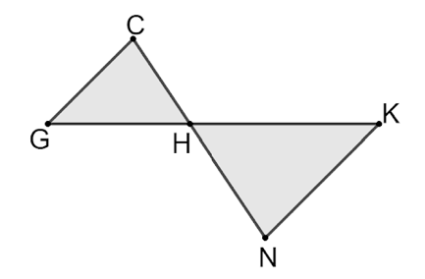
- $∆GHC$ and $∆HNK$ are shown. $\overline{CG}∥\overline{NK}$. What angle is approximately equal to $∠CHG$?

$$∠NHK$$

